<HUB> sample test invoice creation (sop)



Document ID | SOP-HUB-DEV-001
Product | HUB
Environment | DEV
Confidentiality Level | Internal / Restricted

Contents
1 DOCUMENT INFORMATION 3
1.1 Validation 3
1.2 Document Distribution 3
1.3 Version Control 3
2 PURPOSE & CONTEXT 4
2.1 About this document 4
2.2 Scope 4
2.3 Roles & Responsibilities 4
2.4 Terminology 5
2.5 Conventions Used 5
3 Create a sample invoice in hub 6
3.1 Draft Invoice 6
3.1.1 Draft Invoice Preview 7
3.2 Create invoice 8
3.3 Create invoice and submit partial payment 9
3.3.1 Status Workflow 9
3.3.2 Partial payment invoice balance PDF view 10
3.4 Create invoice and submit full payment 11
3.4.1 Status Workflow 12
3.4.2 QuickBase Integration 12
3.4.3 Full payment invoice balance PDF view 13
4 Tax Management 15
4.1.1 Tax Calculation Trigger 15
5 Authorized.net integration 16
5.1 Role in the Invoice Workflow 16
5.2 Payment Application Process in Authorize.net 16
6 Intacct integration 18
6.1 Invoice Creation in Intacct 18
6.2 Payment Application Process in Intacct 19
7 create invoice workflow summary 21
7.1 Workflow Step 21
8 APPROVAL SIGNATURES 23

DOCUMENT INFORMATION

Validation
Name |  | Role | Date (dd/mm/aa)
Issued by | Oscar Rondon | Technical Writer | 31/03/2026
Verified by | Devang Rana | Developer | 31/03/2026
Approved by | Anthony Bures | Digital Development Manager | 31/03/2026

Document Distribution
Normal | Role
Oscar Rondon | Technical Writer
Anthony Bures | Digital Development Manager

Version Control
Version | Date | Author | Description of changes
1.0 | 31/03/2026 | Oscar Rondon | First version of the HUB Test Invoice Creation - SOP document

PURPOSE & CONTEXT

About this document
This document provides a detailed Standard Operating Procedure (SOP) for creating customer invoices within the HUB application. It describes:
- The end-user process for creating invoices
- The system interactions between HUB and external systems
- The payment workflows (no payment, partial payment, full payment)
- The status lifecycle of invoices across systems
This SOP is intended to ensure consistency, accuracy, and traceability in invoice creation and payment processing.

Scope
Scope of the standard operating procedure (SOP)
In scope:
- Invoice creation within HUB (Accounts Receivable module)
- Draft invoice generation from QuickBase line items
- Payment processing via Authorize.net
- Tax calculation via Avalara
- Invoice synchronization with:
  - MySQL (internal database)
  - QuickBase
  - Intacct
Out of scope:
- Manual invoice creation directly in Intacct
- Editing QuickBase line items
- Refunds, voids, or credit memos
- Payment disputes or chargebacks

Roles & Responsibilities
Role | Responsibilities
Account Manager (AM) | Creates invoices, selects line items, initiates payments
HUB System | Orchestrates invoice creation and system integrations
QuickBase | Stores line items, billing data, and invoice records
Authorize.net | Processes and captures payments
Intacct | Handles accounting records and final invoice status
Avalara | Calculates applicable taxes
Cron Job (System Process) | Applies settled payments to Intacct

Terminology
Term Used | Description
Line Item | A product/service entry from QuickBase used to generate invoices
Draft Invoice | A temporary invoice created before final submission
Billing Preference | Stored payment method linked to a customer
Settlement | Finalization of payment in Authorize.net
Cron Job | Scheduled background process that updates payment status
Invoice Status | State of invoice (Posted, Paid, Pending, etc.)

Conventions Used
The following structures are used as recommendations.
Info: Supplementary Information

Tip: A recommendation or useful advice

Warning: A warning or important notice

Note: A notice.

Create a sample invoice in hub

Draft Invoice
This section describes how an Account Manager creates an invoice from available line items.
- Log into the HUB website
- In the left side panel select Accounts Receivable > Invoices > Create Invoice.
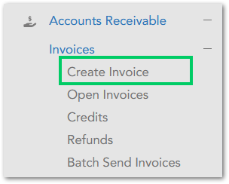
- From the menu, select:
- Account Manager responsible for the customer invoice from the list.
- Company / Customer ID.
- Click the Create Draft Invoice button.
Tip: Make sure to check all the products that are going to be included in the invoice.

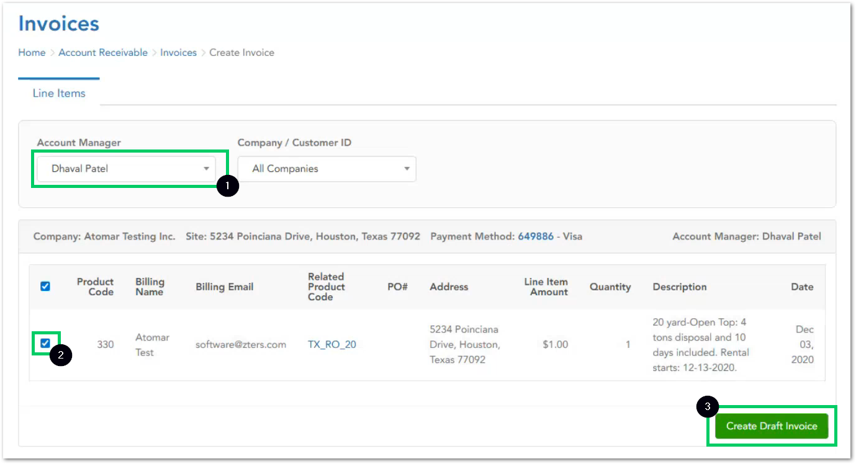

Draft Invoice Preview
- Once the draft invoice is created, the account manager will see the invoice with the following information:
- Invoice number
- Billing information (retrieved from QuickBase line item)
- Aging history
- Site information (retrieved from QuickBase line item)
- Payments applied to the invoice
- Tax (via Avalara)
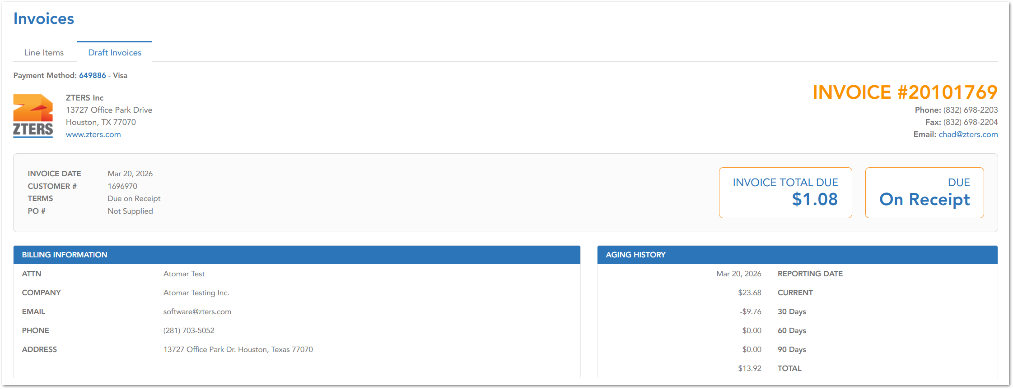
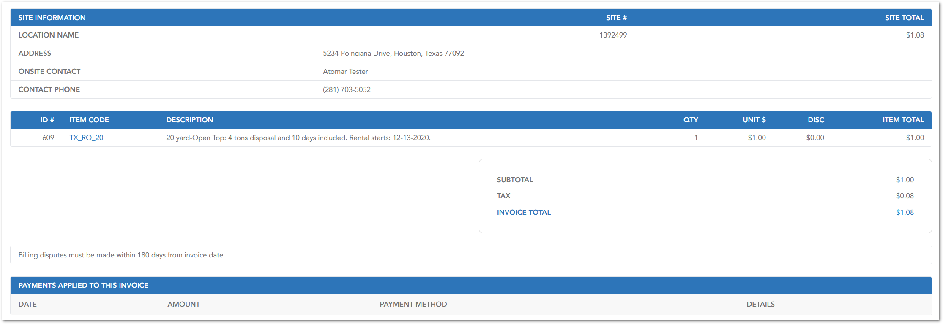

- At the bottom of the page the account manager will find 3 buttons:
- Create invoice
- Create invoice and submit partial payment
- Create invoice and submit full payment

Create invoice
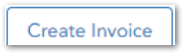
The Create Invoice button allows the Account Manager to generate an invoice without applying any payment at the time of creation. This option is typically used when:
- The invoice will be paid later
- The invoice needs to be reviewed before payment

When this option is selected, the HUB system performs the following operations:
Operation | Description
MySQL (Internal Storage) | A new invoice record is created in the HUB database, the invoice number is generated sequentially, and Line items are linked to the invoice
QuickBase | The invoice is created and associated with the original line item, the invoice number is stored in the corresponding QuickBase record, and the relationship between line item ↔ invoice is established
Intacct (Accounting System) | The invoice is created via API integration, and the invoice is recorded under Accounts Receivable.

Note: No interaction with Authorize.net occurs in this flow. The invoice will remain unpaid until payment is manually applied or processed later

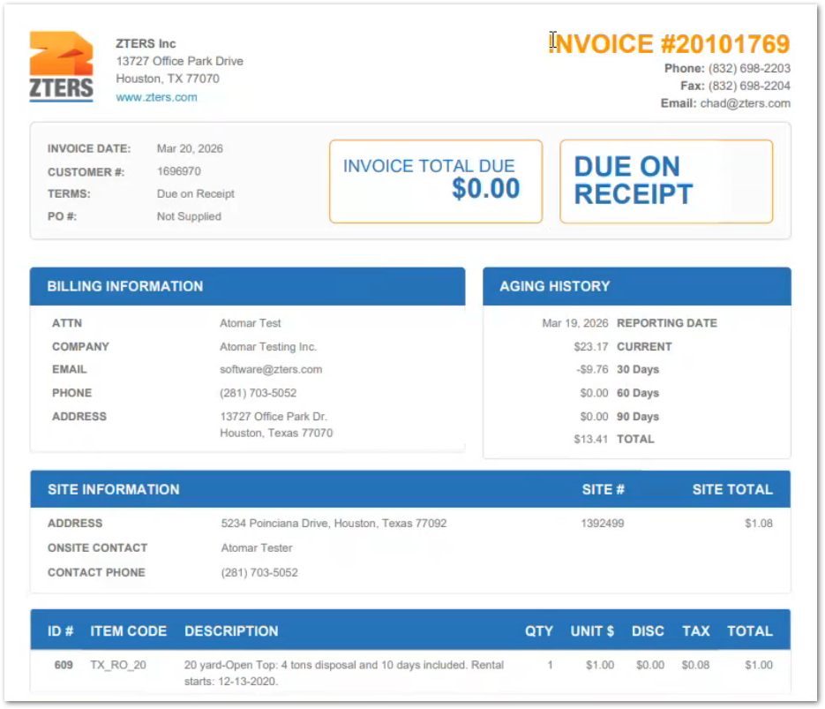

Create invoice and submit partial payment
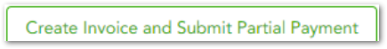
The Create Invoice and Submit Partial Payment button allows the Account Manager to generate an invoice and apply a partial payment immediately. This option is typically used when:
- The rest of the invoice will be paid later
- The remaining amount will be paid using a different payment method
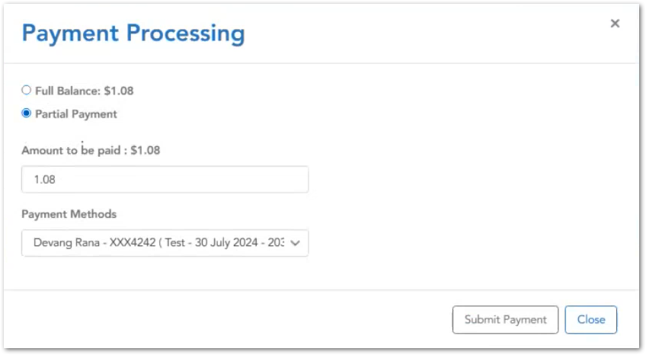

When this option is selected, the HUB system performs the following operations:
Operation | Description
MySQL (Internal Storage) | A new invoice record is created in the HUB database, the invoice number is generated sequentially, and Line items are linked to the invoice
QuickBase | The invoice is created and associated with the original line item, the invoice number is stored in the corresponding QuickBase record, and the relationship between line item ↔ invoice is established
Intacct (Accounting System) | The invoice is created via API integration, and the invoice is recorded under Accounts Receivable.

Once the partial payment has been applied, HUB displays a confirmation message at the top:
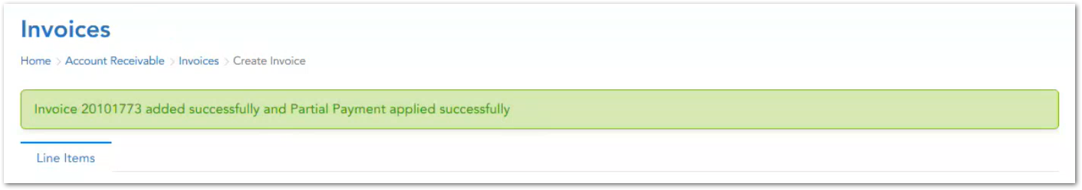

Status Workflow
The status in every application after applying
Application | Initial Status | Final Status
Intacct | Posted | Paid (after the transaction cut-off time)
Authorized.net | Captured/Pending Settlement | Settled Successfully (after payment is applied)
HUB | Partial Payment Applied | Paid

Partial payment invoice balance PDF view
In QuickBase, within the Invoices > Invoice 20101773, the user can check the PDF file of the invoice. Remember that the invoice total remains partially unpaid, and the remaining balance is tracked.
Warning: The payment is not yet finalized until settlement occurs and the remaining balance must be collected later.
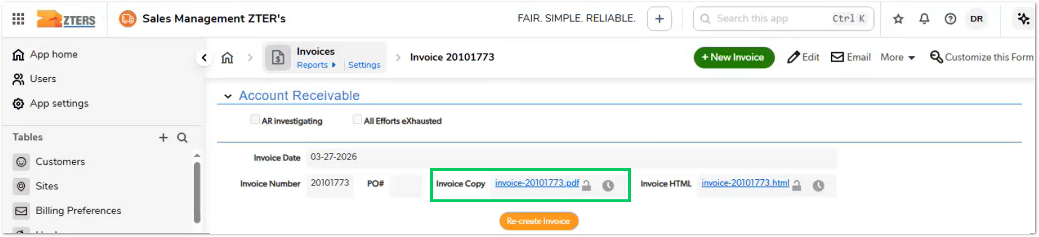
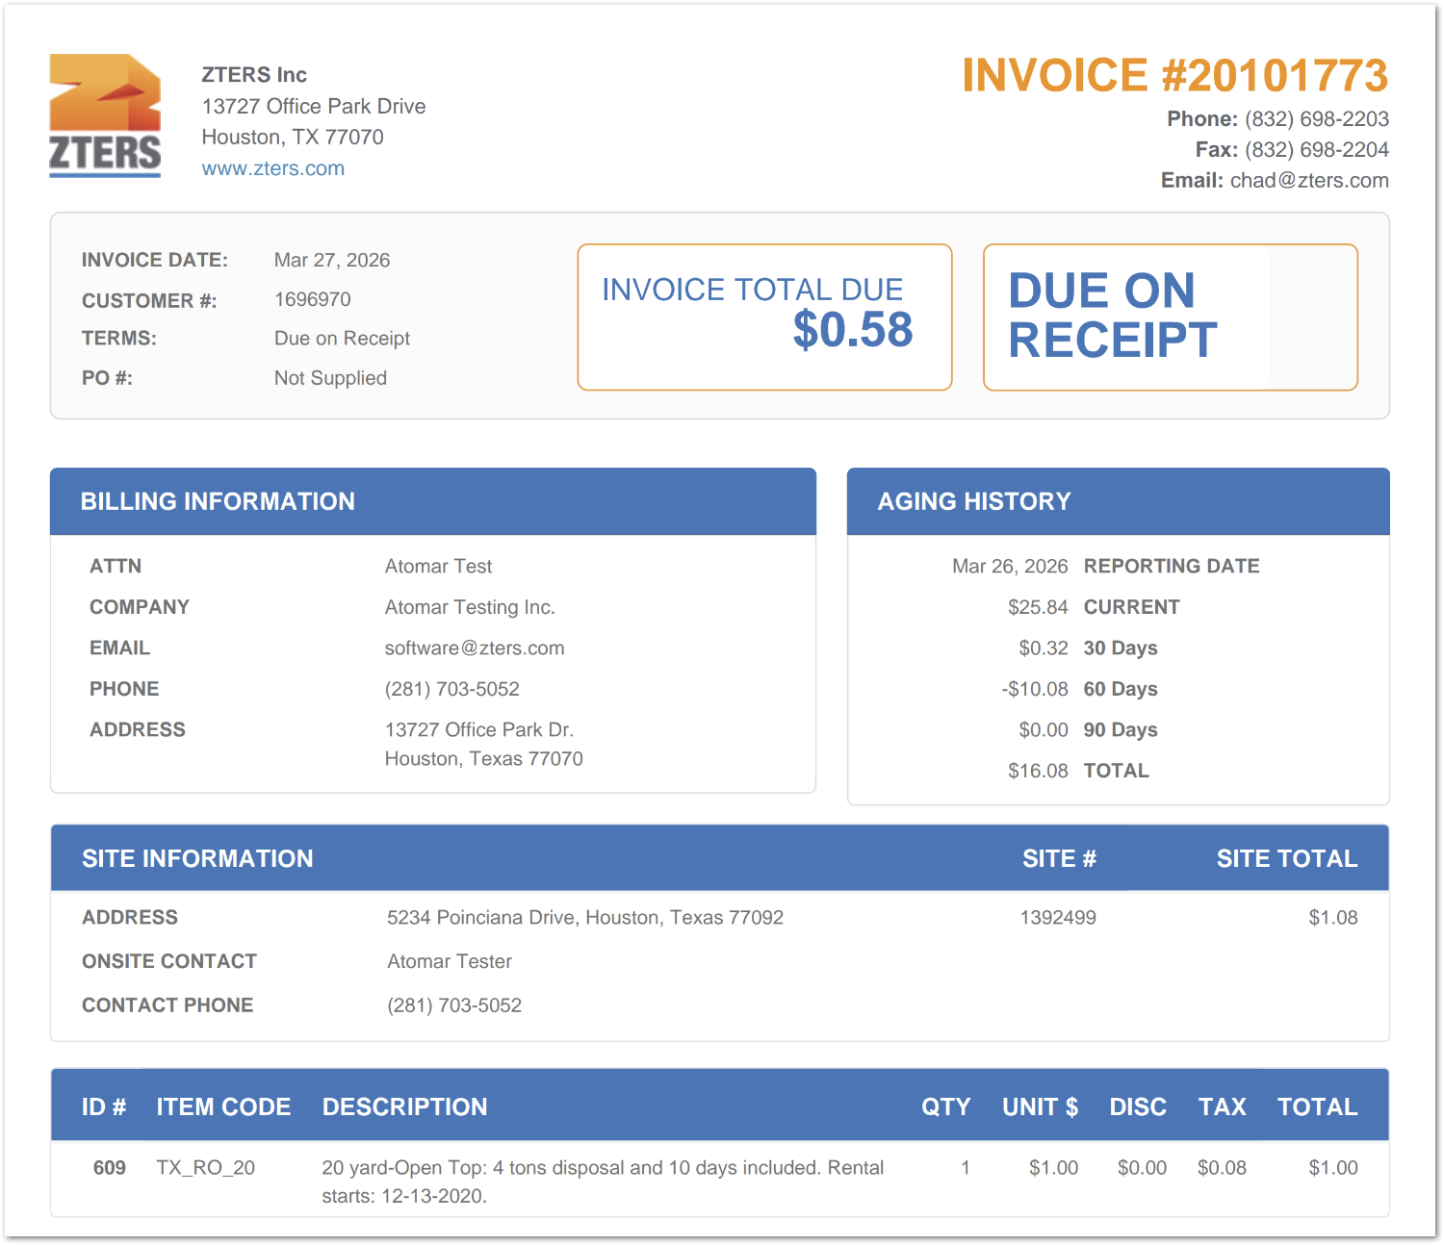
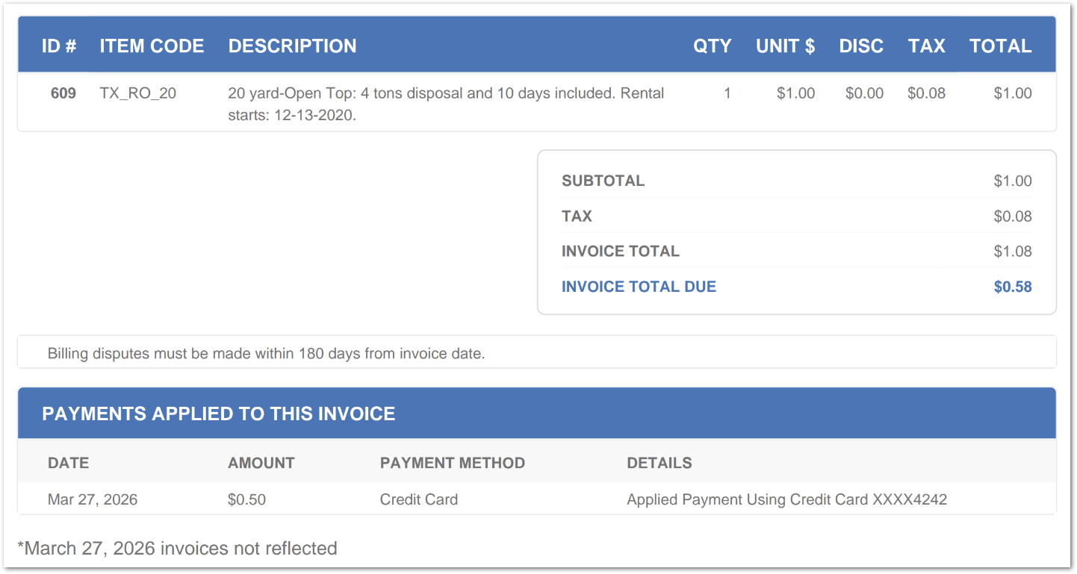
As you can notice, the invoice total due $0.58 since we applied a partial payment of only $1.08 to the invoice at first.
Tip: The account manager always has the option to apply another partial payment or the full payment to the due amount, using the same or a different payment method.

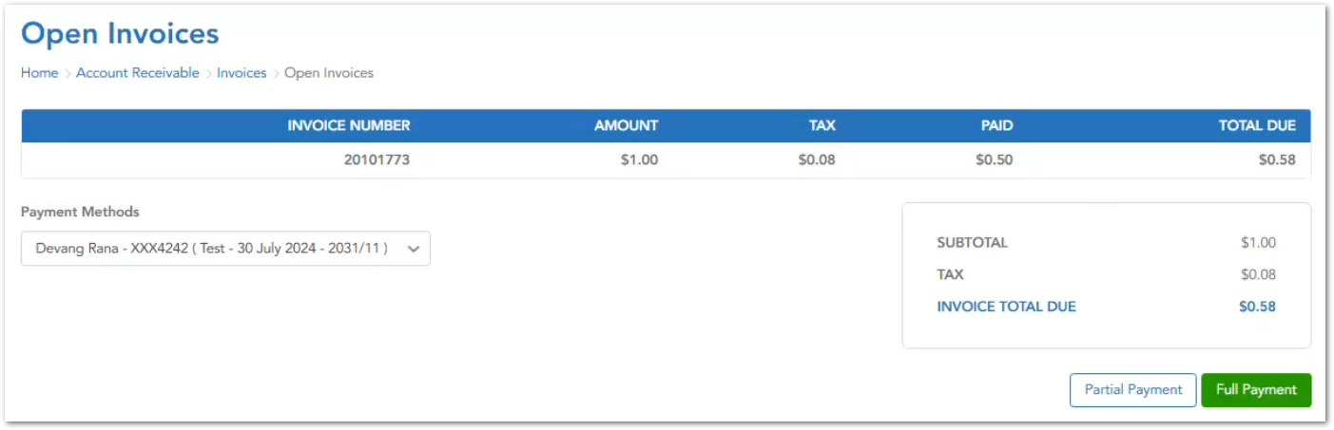

Create invoice and submit full payment
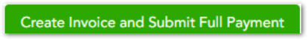
The Create Invoice and Submit Full Payment button allows the Account Manager to generate an invoice and apply a total payment immediately.

When this option is selected, the HUB system performs the following operations:
Operation | Description
MySQL (Internal Storage) | A new invoice record is created in the HUB database, the invoice number is generated sequentially, and Line items are linked to the invoice
QuickBase | The invoice is created and associated with the original line item, the invoice number is stored in the corresponding QuickBase record, and the relationship between line item ↔ invoice is established
Intacct (Accounting System) | The invoice is created via API integration, and the invoice is recorded under Accounts Receivable.

Once the full payment has been applied, HUB displays a confirmation message at the top:
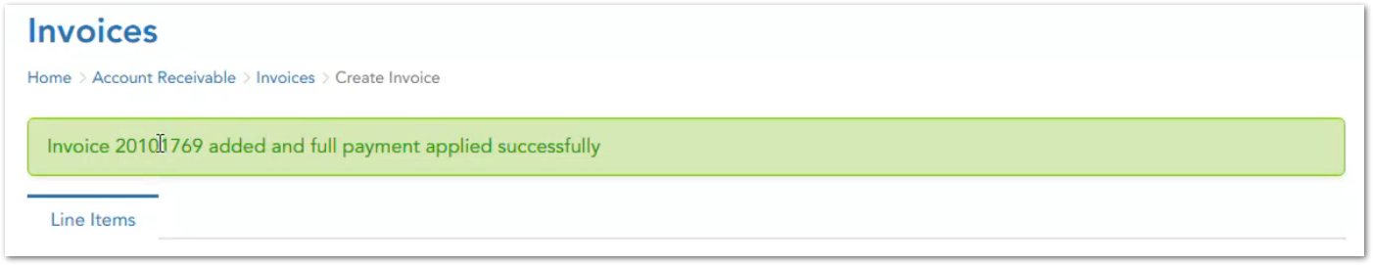
Warning: At this point payment is captured but not settled and the invoice is not yet marked as Paid in Intacct:
- During the day: Payments are captured
- After cutoff time (~6 PM CT): Payments are settled

Status Workflow
The status in every application after applying
Application | Initial Status | Final Status
Intacct | Posted | Paid (after the transaction cut-off time)
Authorized.net | Captured/Pending Settlement | Settled Successfully (after payment is applied)
HUB | Partial Payment Applied | Paid (pending settlement)

Once the full payment is processed, the transaction is displayed in authorized.net under the order history tab. Each transaction includes the following data:

QuickBase Integration
In the example case, we used the Line Item #609 in QuickBase. After refreshing the page, we will be able to see the related invoice number under Line Items > Line Item #609.
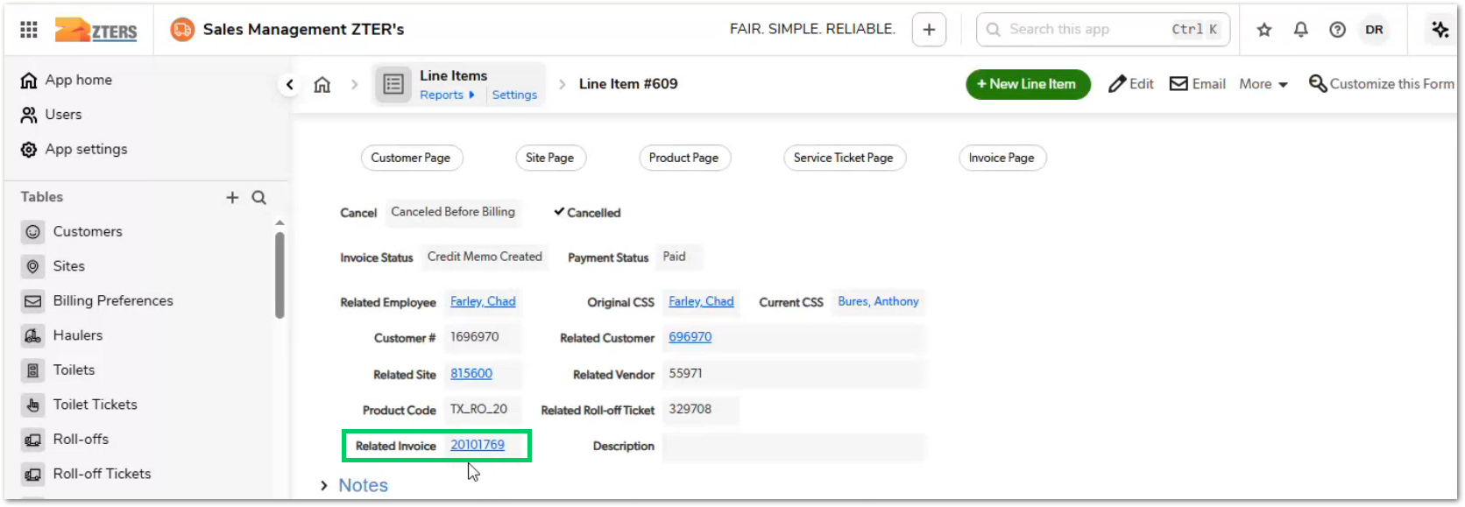
If we open the invoice, we will be able to see
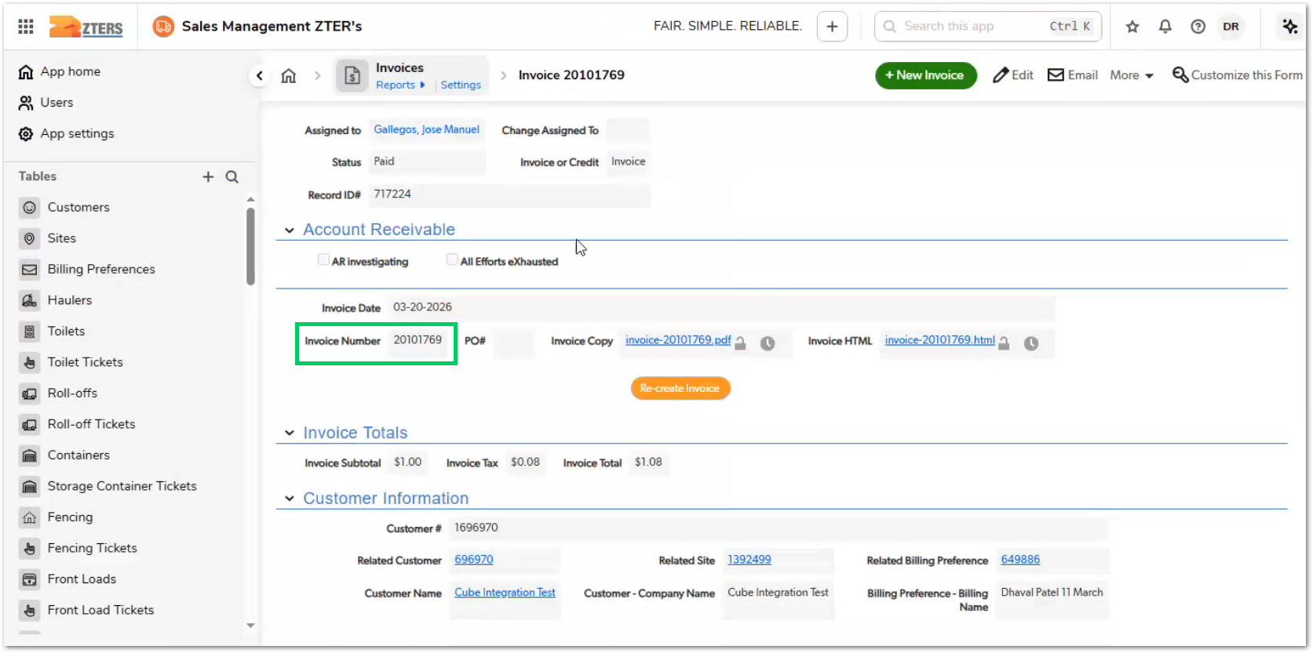
In QuickBase, under the transactions tab, there will be information related to the authorize.net transaction id.
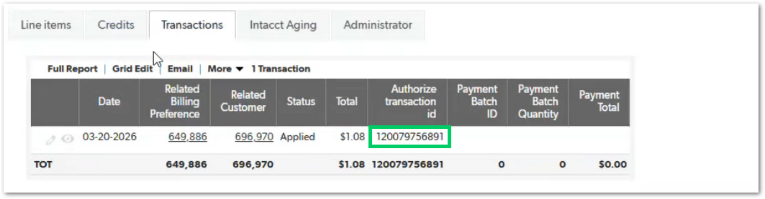

Full payment invoice balance PDF view
In QuickBase, within the Invoices > Invoice 20101769, the user can check the PDF file of the invoice.
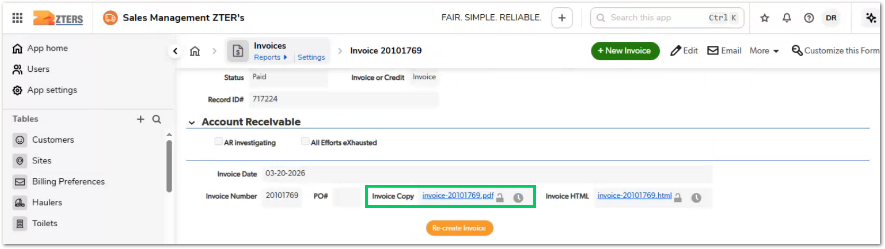

As you can notice, the invoice total due is zero (0) since we applied full payment to the invoice. We also have billing information, aging history, site information, and invoice ID information. Notice that the ID# is 609, which is the same code as the line item in QuickBase.

Tax Management
The tax calculation for invoices generated in HUB is handled through an external integration with Avalara, a third-party tax compliance and calculation service. This ensures that all tax amounts applied to invoices are accurate, compliant with regional regulations, and dynamically calculated based on real-time data.
When an invoice is created or a draft invoice is generated, HUB does not calculate tax internally. Instead, it delegates this responsibility to Avalara, which determines the appropriate tax amount based on multiple variables associated with the transaction.

Tax Calculation Trigger
The tax calculation is triggered when the user clicks Create Draft Invoice:
- HUB gathers all relevant invoice data
- A request is sent to Avalara via API
- Avalara returns the calculated tax, based on:
- Jurisdiction (country, state, city, ZIP code)
- Product/service taxability rules
- Applicable tax rates or exemptions
- The tax is displayed in the draft invoice
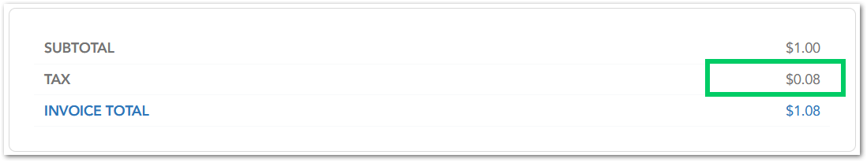

Authorized.net integration
Authorize.net is the payment processing system used within the HUB invoice workflow to handle credit card transactions and payment authorization. It is responsible for capturing payments when invoices are created with either partial or full payment options.
The integration between HUB and Authorize.net enables secure handling of customer payment methods, transaction processing, and payment tracking, while ensuring that sensitive payment data is not directly managed within HUB.

Role in the Invoice Workflow
Authorize.net is involved only when a payment is initiated, specifically when the user selects:
- Create Invoice and Submit Partial Payment
- Create Invoice and Submit Full Payment
Warning: Authorized.net is not involved when the user selects Create Invoice (no payment) from the draft invoice window.

Payment Application Process in Authorize.net
- Before any payment can be processed, a valid payment method must exist for the customer. Payment methods are stored as billing preferences, associated with the customer in:
- QuickBase
- HUB (MySQL)

- When a payment method is created:
- A customer profile and payment profile are created in Authorize.net
- HUB stores references to these profiles (tokens/IDs), not the actual card data

- Once the payment is initiated from HUB, it retrieves the payment profile
- Customer profile ID
- Payment profile ID

- HUB sends a payment transaction request to Authorize.net, which includes:
- Invoice amount (full or partial)
- Customer/payment profile
- Transaction metadata

- Authorized.net processes the request and place the payment as captured (if successful). A transaction ID is generated during the step.
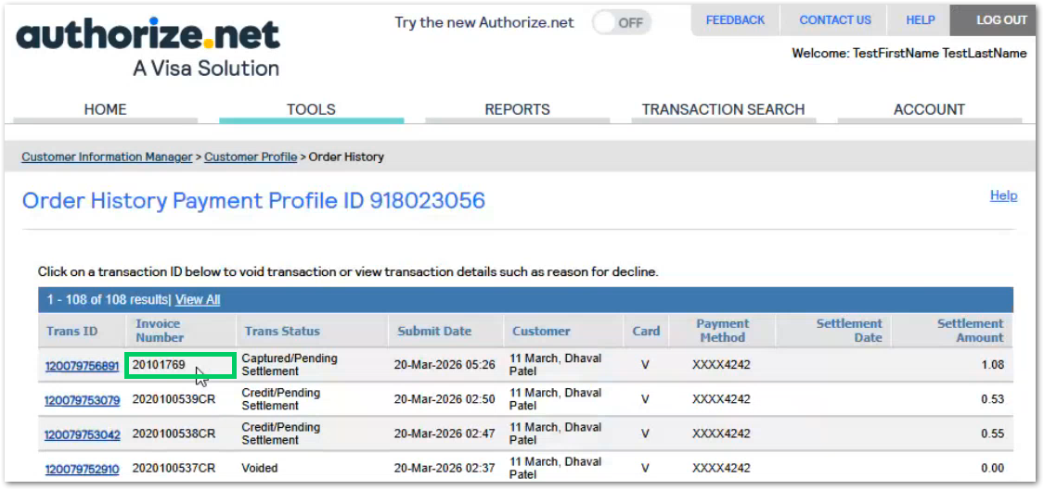

- The transaction ID gets stored in HUB (MySQL) and QuickBase (linked to invoice). Within authorized.net the invoice number and transaction data is all connected.
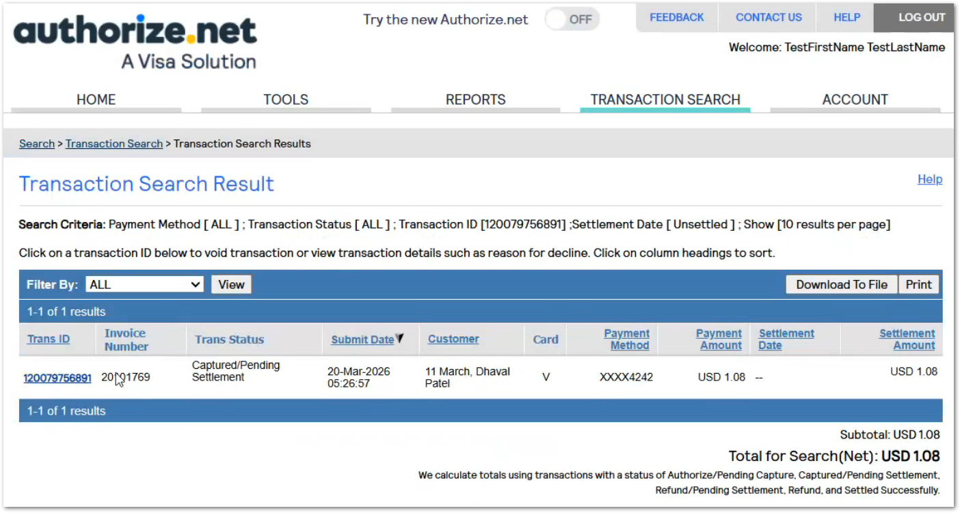

Intacct integration
The Intacct serves as the system of record for accounting and financial reporting within the invoice creation process. All invoices generated in the HUB application are automatically synchronized with Intacct to ensure accurate financial tracking, reporting, and reconciliation.
The integration between HUB and Intacct is managed through API communication, with HUB acting as the orchestrator that controls when and how invoice and payment data are transmitted.

Invoice Creation in Intacct
Whenever an invoice is created in HUB, a corresponding invoice record is automatically created in Intacct. Invoice creation in Intacct is triggered when the user selects any of the following options:
- Create Invoice
- Create Invoice and Submit Partial Payment
- Create Invoice and Submit Full Payment
Regardless of the selected option, the invoice creation step in Intacct occurs before any payment is applied. Once the invoice is successfully created in Intacct, you can see it under the Applications > Accounts Receivable > Invoices module.
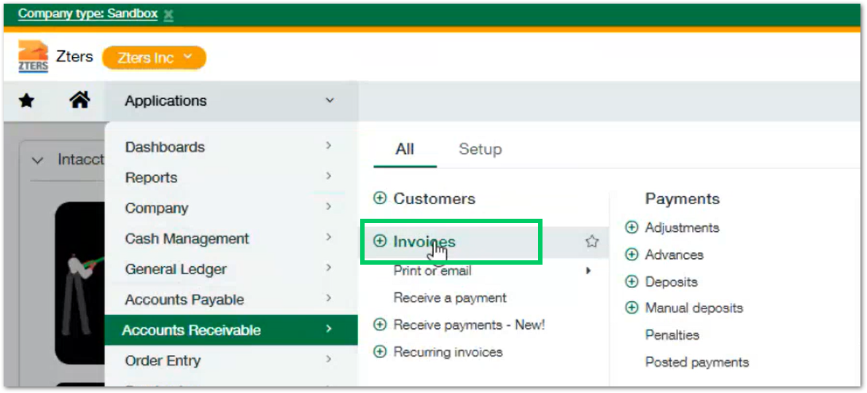
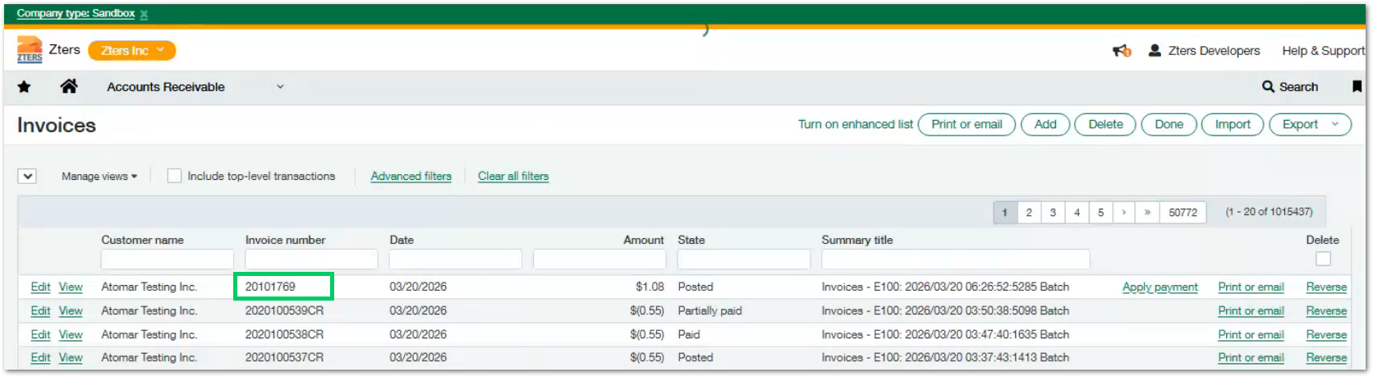
Info: At this stage the invoice is considered valid and active.

Payment Application Process in Intacct
Although payment may be initiated from HUB during invoice creation, it is not immediately reflected in Intacct.
- Payment is processed through Authorize.net

- The transaction is captured and assigned a status:
- Captured / Pending Settlement

- At this stage:
- The payment exists in Authorize.net
- The invoice in Intacct remains Posted
- We will see the following details in the invoice’s view details button
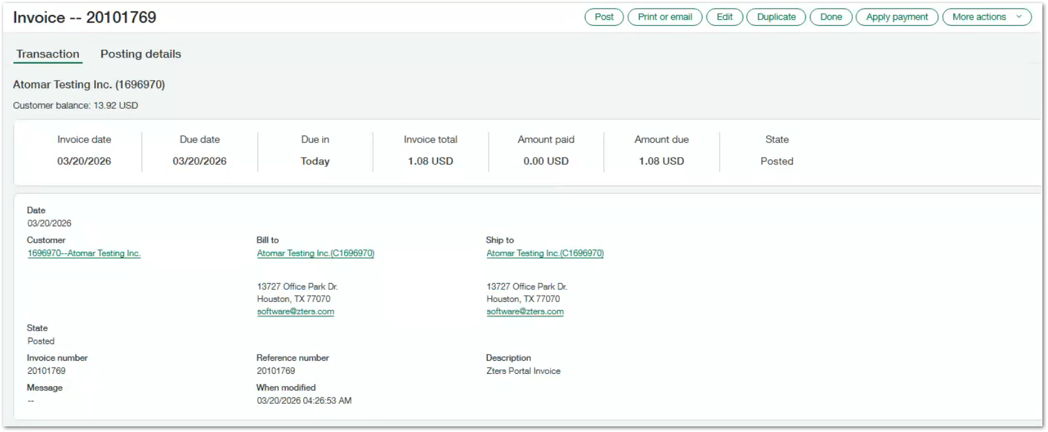
- Then, Authorize.net processes payments in batches and finalizes transactions during settlement (after the daily cutoff time)

- After settlement:
- A scheduled cron job runs within HUB and the system retrieves settled transactions from Authorize.net. Then, HUB sends a request to Intacct to apply the payment

- Once the payment is applied, the status will change in intacct to PAID as follows:
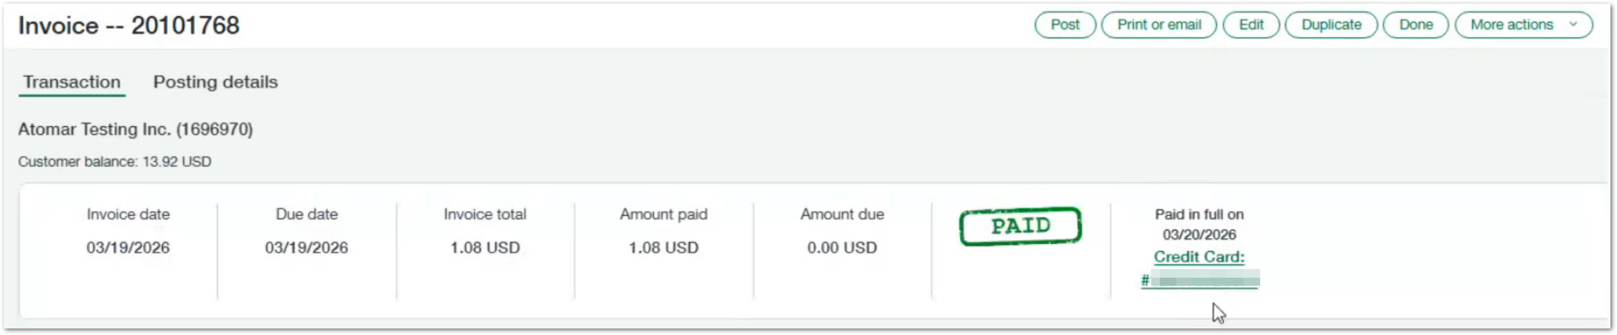
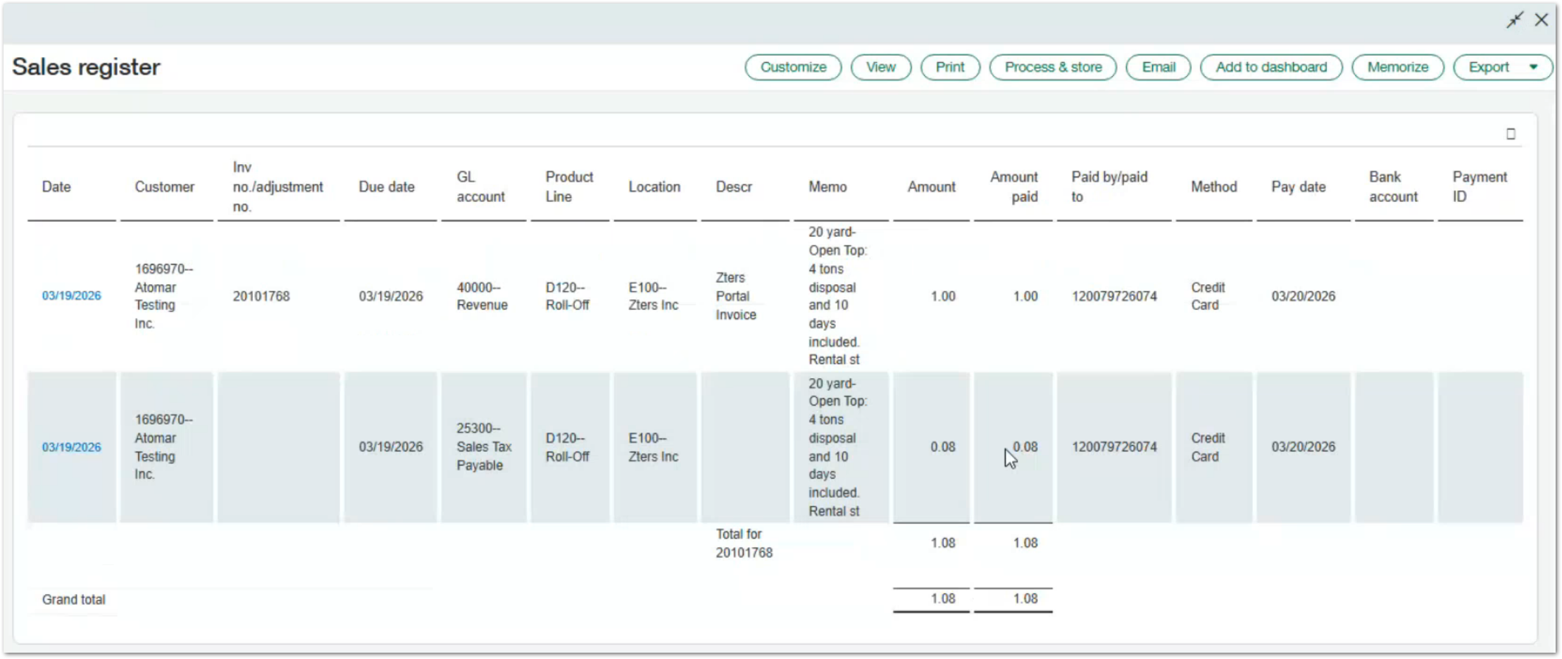
Note: The invoice status is updated from posted to PAID, it indicates that the invoice balance has been fully satisfied

create invoice workflow summary
This section provides a high-level overview of the steps an Account Manager follows to create an invoice within the HUB application. It focuses on the user interaction flow, from accessing the feature to selecting the desired invoice creation option.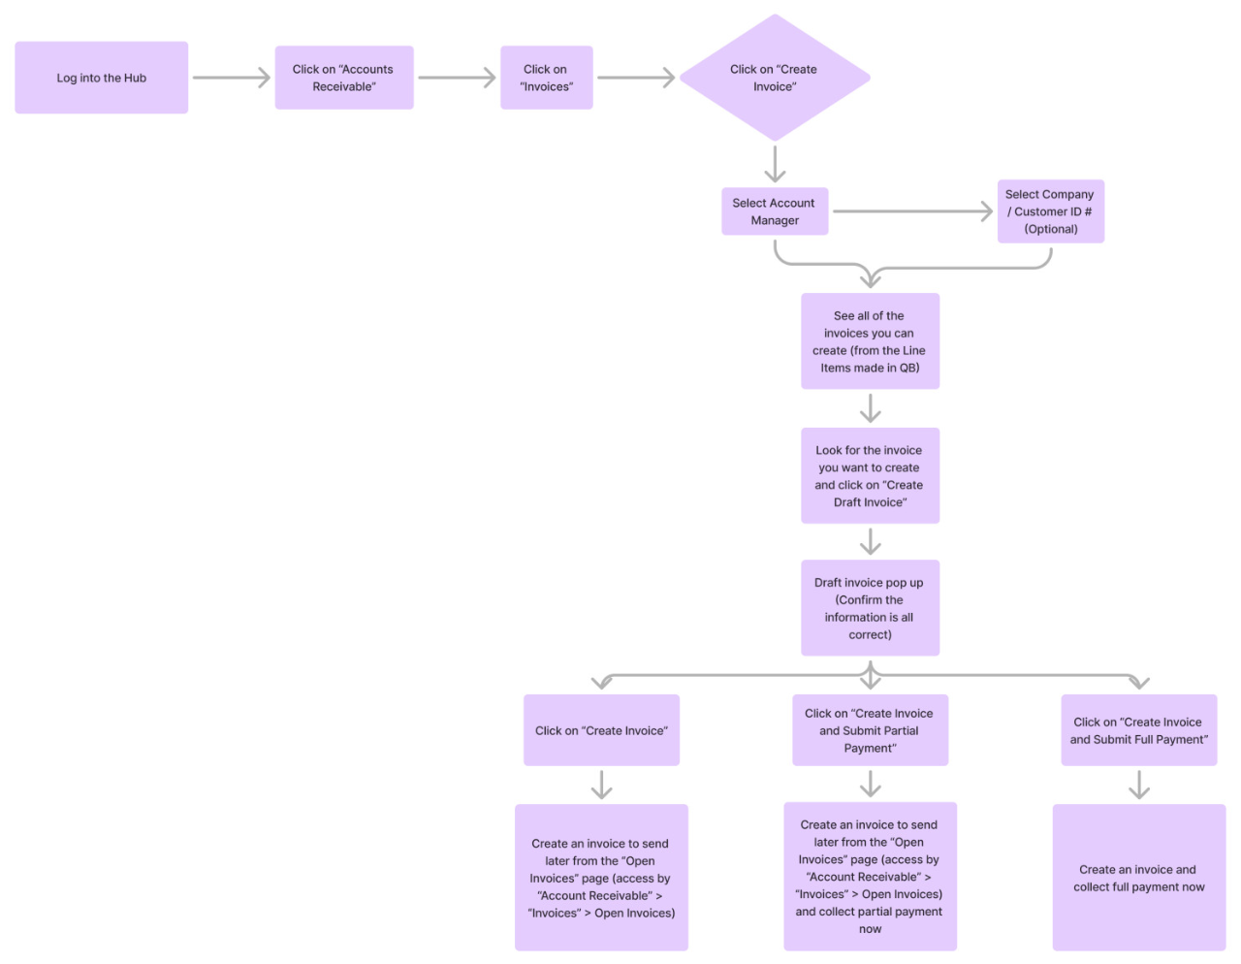

Workflow Step
At a high level, the process follows these steps:
Step | Process | Description
1 | Retrieve line items from QuickBase | HUB retrieves all eligible line items from QuickBase that are available for invoicing. These typically include completed services or billable products that have not yet been associated with an invoice.
2 | Cache data in MySQL | Retrieved line item data is temporarily stored in the HUB database (MySQL) to improve performance and reduce repeated calls to QuickBase during the invoice creation process.
3 | Display grouped line items | HUB displays the available line items in the user interface, grouped logically (e.g., by customer, site, or service type) to facilitate selection and invoice creation.
4 | Create draft invoice | The user selects one or more line items and initiates the creation of a draft invoice. HUB prepares a preliminary invoice containing billing details, site information, and selected line items.
5 | Calculate tax (Avalara) | HUB sends the draft invoice data to Avalara, which calculates the applicable tax based on location, product type, and transaction details. The calculated tax is returned and displayed in the draft invoice.
6 | User selects action | After reviewing the draft invoice, the user selects one of the available actions: create the invoice without payment, apply a partial payment, or apply full payment.
7 | Create invoice in all systems | HUB finalizes the invoice and creates corresponding records across integrated systems, including internal storage (MySQL), QuickBase (for record linkage), and Intacct (for accounting).
8 | Process payment (optional) | If a payment option is selected, HUB submits the transaction to Authorize.net using the customer’s stored payment profile. The payment is captured and a transaction record is generated.
9 | Wait for settlement | Payments processed through Authorize.net remain in a pending state until they are settled during the daily batch process. During this time, the invoice remains open or posted in the accounting system.
10 | Cron job applies payment | After settlement, a scheduled HUB process (cron job) retrieves the finalized transactions and applies the payment to the invoice in Intacct, updating its status accordingly.

Note: This workflow summarizes the end-to-end process of invoice creation, from data retrieval to final payment synchronization across all integrated systems.

APPROVAL SIGNATURES
Digital signature blocks below are formatted for DocuSign / Adobe Sign.
Name | Role | Digital Signature Block | Date (dd/mm/aa)
Anthony Bures | Digital Development Manager |  | 31/03/2026

--- END OF THE DOCUMENT ---

